Assignment Submission Document for the Final Project

**Paste a screenshot of your form in the IDE below (Program not running):**

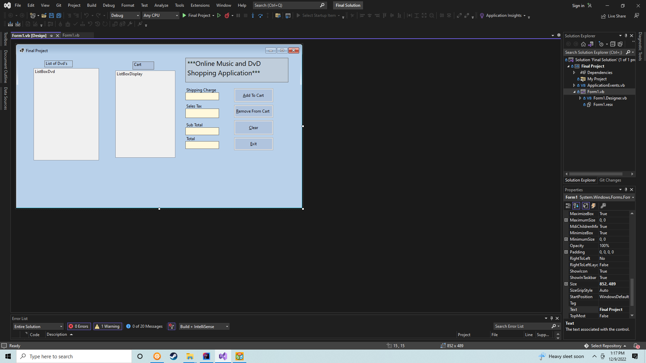

**Paste your program code below:**

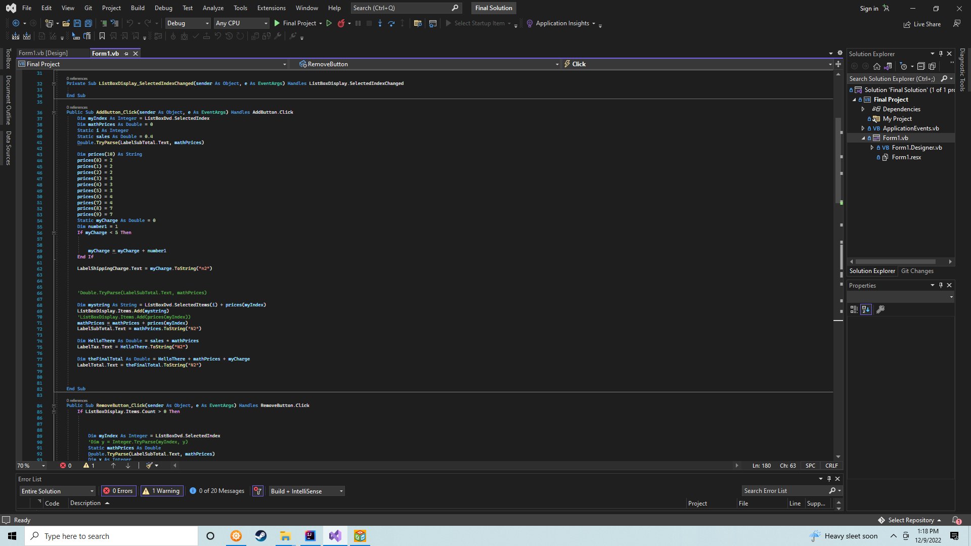



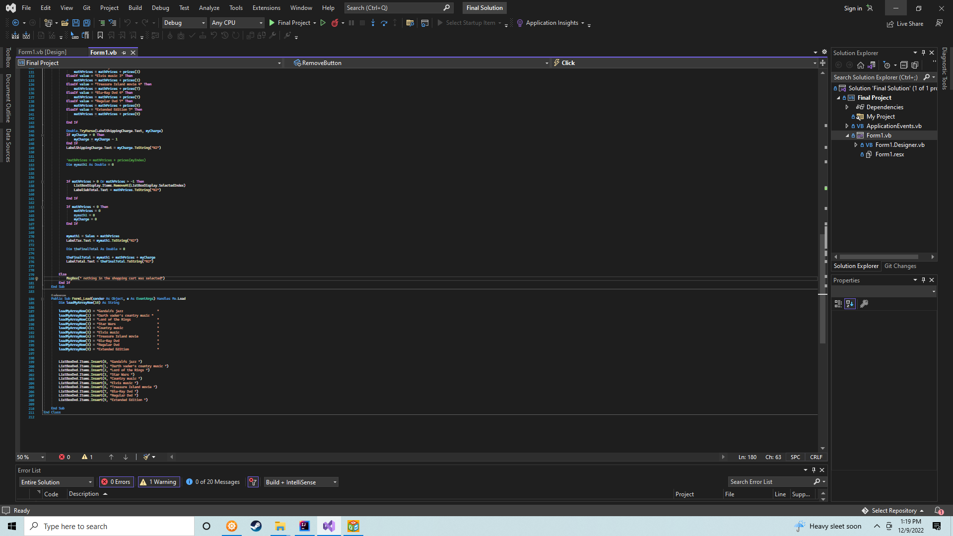

**Paste at least 3 screen shots of your application running. Before adding to the cart, after adding at least 3 items to the cart, and after removing an item from the cart.**

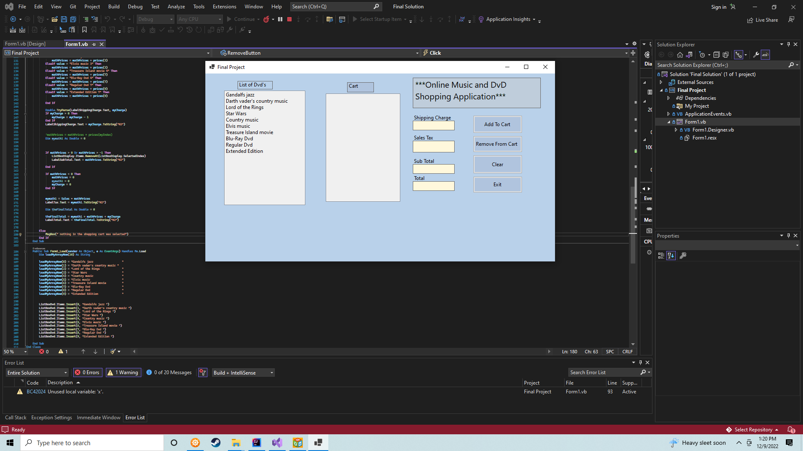

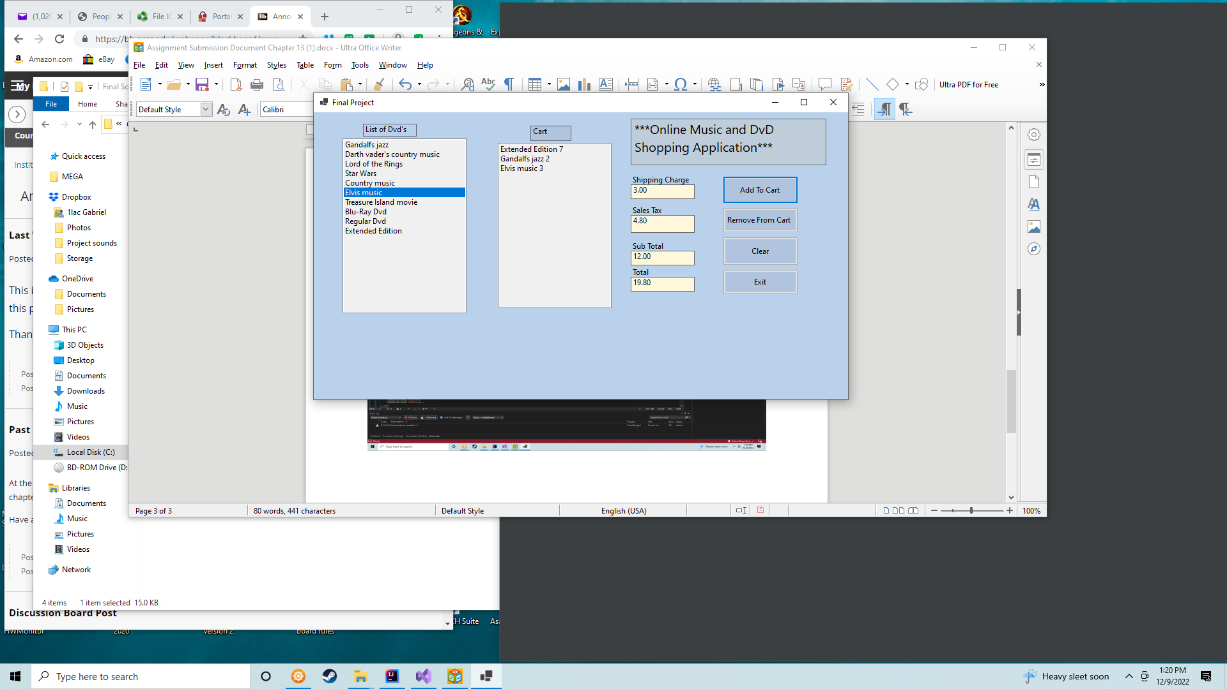

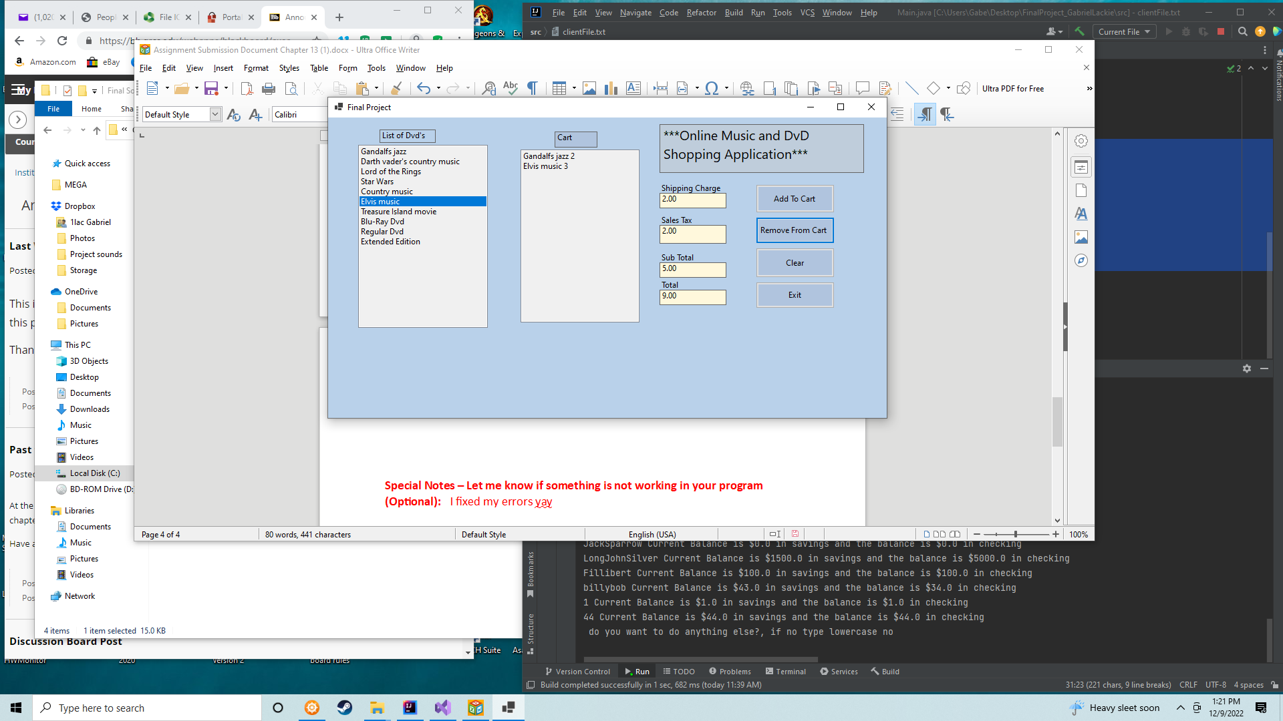

**Special Notes – Let me know if something is not working in your program (Optional):** I fixed my errors yay